

**Specification Document**

**Project Name: Meal Mate**

**Team Number 33**

|  |  |  |
| --- | --- | --- |

**Document Information**

|  |  | | |
| --- | --- | --- | --- |
| **Project Name:** | Meal Mate | | |
| **Prepared By (list all authors):** | Rhys March, Finnigan Dowling, Hamzeh Edlebi, Ali Ibrahim Mostafa Kamel Khali, Bryant Sujantho, Charlie Robinson | **Preparation Date:** |  |
|  |  |  |  |
| **Document Version No:** | 0.18 | **Document Version Date: 19/05/2023** |  |
|  |  |  |  |

**Version History**

| **Ver. No.** | **Ver. Date** | **Revised By** | **Description** |
| --- | --- | --- | --- |
| 0.1 | 23/04/2023 | Rhys March | Setup the document, and added the deliverables |
| 0.2 | 27/04/2023 | Bryant Sujantho | Added Deliverables, Analysis, Hardware and Software specifications and functional requirements |
| 0.3 | 27/04/2023 | Finn Dowling | Created system architecture lucid chart in software specifications. |
| 0.4 | 27/04/2023 | Ali Khalil | Created draft of Testing Methodology |
| 0.5 | 28/04/2023 | Rhys March | Updated the deliverables |
| 0.6 | 17/05/2023 | Bryant Sujantho | Added other considerations, gave some term definitions and added a deployment diagram |
| 0.7 | 18/05/2023 | Hamzeh Edlebi | Finalised 9.5 GUI, Human Interface Views and added term definition |
| 0.8 | 18/05/2023 | Finn Dowling | Modifications and additions to functional and non-functional requirements. |
| 0.9 | 19/05/2023 | Bryant Sujantho | Added description for the deployment diagram |
| 0.10 | 19/05/2023 | Rhys March | Updated software requirements, and also did proofreading |
| 0.11 | 19/05/2023 | Rhys March | Added screenshots & descriptions for the screenshots in the background and analysis section |
| 0.12 | 19/05/2023 | Rhys March | Updated the table of contents and figures pages |
| 0.13 | 19/05/2023 | Ali Khalil | Updated the deliverables and functional requirements |
| 0.14 | 19/05/2023 | Rhys March | Improved the layout and design of the document |
| 0.15 | 19/05/2023 | Bryant Sujantho | Added References, made 9.4, updated pictures for part 9.5 and modified ID in solution requirements |
| 0.16 | 19/05/2023 | Rhys March | Added the contribution matrix |
| 0.17 | 19/05/2023 | Finn Dowling | Created component diagram. |
| 0.18 | 19/05/2023 | Finn Dowling | Description of System architecture Diagram, Component Diagram. |

**Table of Contents**

**1. Background & Analysis 5**

**2. Deliverables 7**

**3. Project Plan 8**

**4. Hardware and software platforms to be used for developing and running your solution 9**

**5. References 10**

**6. Definition of terms 11**

**7. Solution requirements 12**

**8. Other considerations 13**

**9. Software Design 14**

**10. Testing Methodology 21**

**[Team 33] 3**

**Table of Figures**

| Figure | Description | Page |
| --- | --- | --- |
| 1 | Too Good to Go app, page of businesses selling food at a discounted price | 5 |
| 2 | Foodiverse app, statistics page | 5 |
| 3 | Hacks page on the kitche website, food ‘hacks’ for reducing food waste | 6 |
| 4 | Food hack example on kitche | 6 |
| 5 | Gantt Chart project plan | 8 |
| 6 | Architecture diagram | 13 |
| 7 | Deployment diagram | 14 |
| 8 | Component diagram | 15 |
| 9 | Package and class diagram | 16 |
| 10 | Activity diagram | 16 |
| 11 | Home page | 16 |
| 12 | Login page | 17 |
| 13 | Account creation page | 17 |
| 14 | Recipe maker AI page | 18 |
| 15 | Forum page | 18 |

# Background & Analysis

* 1. **Analysis**

This describes the business environment that the project would typically fit into**.**

**1.1.1 Analysis 1 - Too Good To Go**

Too Good To Go is an app that was launched in 2015 and it aims to reduce food waste by connecting consumers with local businesses that have a surplus of food at the end of the day at a discounted price. This provides a win-win solution for both the businesses and consumers as the business can reduce their food waste and losses, while their customers get cheaper meals. The app caters to a growing consciousness and awareness among its users regarding environmental and social issues like food waste and sustainability. The app has a rating and review system that allows the users to provide feedback on the food which helps encourage’s the business to maintain high standards. Too Good To Go has also partnered with multiple companies like ALDI, Deliveroo, etc. Despite its success, the app has multiple challenges, including gaining the trust of new businesses and ensuring the quality of food offered. Since the app has a rating and review system, it is susceptible to fake reviews, which could potentially undermine the trust between the app/user and the businesses.

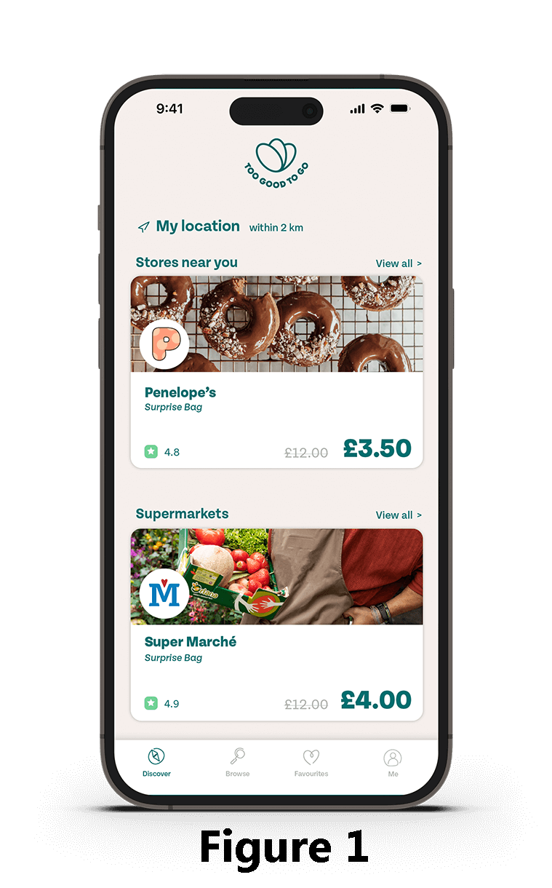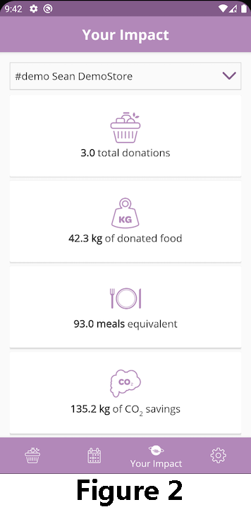

Figure 1 (7) shows how businesses registered on the app can sell their food at discounted prices instead of wasting it. Meal Mate aims to create a similar platform but with a more casual approach. Users can specify a location and describe the food they wish to give away. While Too Good To Go sells food at a price, Meal Mate allows food to be given away for free.

**1.1.2 Analysis 2 - Foodiverse**

Foodiverse is a business enterprise that aims to connect local businesses like grocery stores and restaurants with surplus food to charities and local communities. Foodiverse helps businesses minimise food waste to organisations that can distribute it to those in need. This can cause the businesses to save money as it potentially reduces waste disposal costs and they could also benefit from a tax cut. Foodiverse also helps increase awareness about food waste and the importance of sustainable food practices. Foodiverse has a chat feature that allows the donor and recipient to communicate with each other regarding the availability of the food.

Figure 2 (3), shows figures about what could be a user or a store, including total donations, CO2 saved and more. A similar feature could be implemented into Meal Mate, encouraging users to donate more.

**1.1.3 Analysis 3 - Kitche**

Kitche is an app that aims to reduce food waste in households by keeping track of the groceries they have. The app works by allowing the users to scan the grocery receipts or manually add them. This helps the users to keep track of the food they have in their pantry. The app could also give recipe suggestions depending on the ingredients they have. This further helps the users to make the most of their food and reduce the need to buy additional ingredients. Kitche also provides insights to the user by showing the amount of food that they have saved from going to waste and the money they have saved as a result of them using the app. The app, however, needs to improve on encouraging the users and giving them incentives to be using their app daily.

Figure 3 (1), shows a page on the kitche website that includes a variety of food hacks to stop food waste and when clicking one of the hacks, you're taken to a page that includes a video about the hack. An example is shown in figure 4 (4). This is part of what Meal Mate is all about, reducing food waste, and we will use this to inspire us.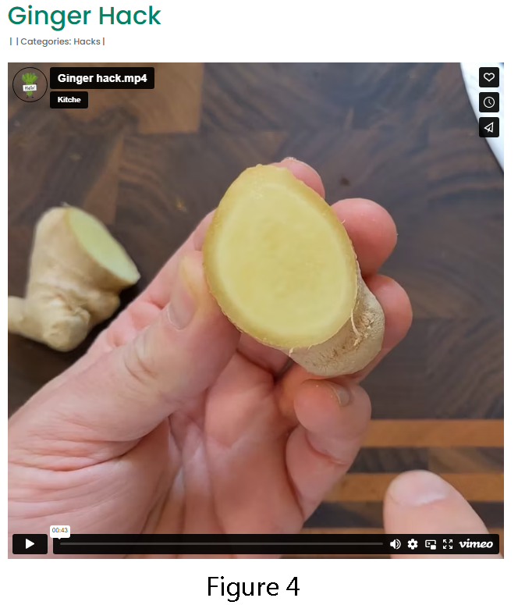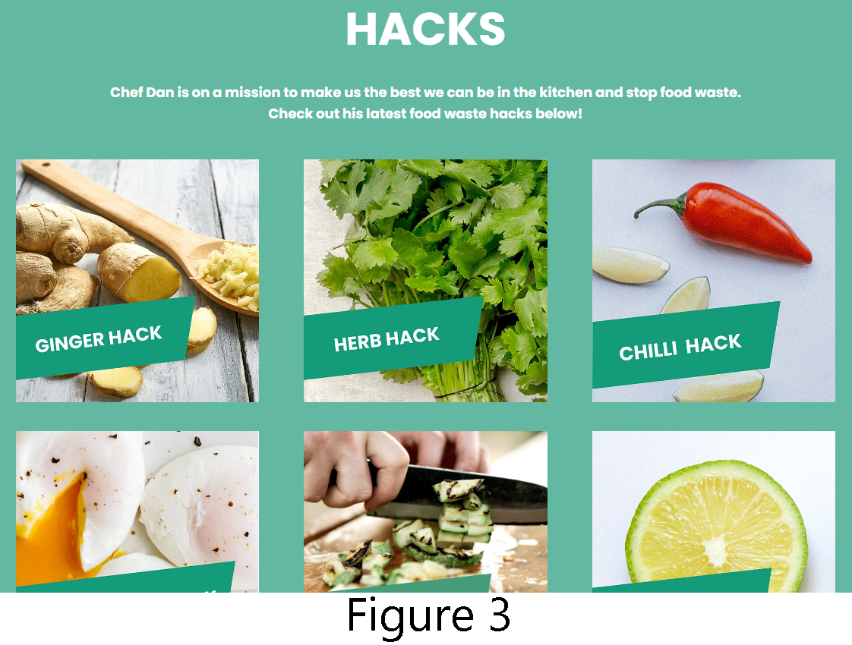

# Deliverables

We aim to deliver a comprehensive website that offers a range of features to help people connect with others, save money, and eat healthily. Here is what our website will provide:

1. **Home Page**: The page that describes our website, our aim, and buttons to access other pages. This deliverable will be expected to be delivered on *04/05/2023*.
2. **Login/Logout Function**: Users can create accounts and login/log out to use certain features. This deliverable will be expected to be delivered on *08/05/2023*.
3. **Account Functionality**: Users can manage their profiles, view their posts, and use certain features that require an account. This deliverable will be expected to be delivered on *15/05/2023*.
4. **Forum**: A space for people to create forums to discuss and connect with others. Users can talk about anything, but food talk, tips, etc will be encouraged. This deliverable will be expected to be delivered on *19/05/2023*.
5. **Map-Based Food Posting**: Separate page for users to post their spare food, with an interactive map showing the approximate location of the food. The post will remain visible until the poster removes it, or the food is marked as taken. Also includes locations of local food banks. This deliverable will be expected to be delivered on *15/05/2023*.
6. **Recipe** **Maker** **AI**: A page that has a feature that recommends recipes based on the ingredients users have on hand. This deliverable will be expected to be delivered on *12/05/2023*.
7. **Price** **Comparison** **Page**: A page that compares the prices of products that are sold in multiple different popular shops. This deliverable will be expected to be delivered on *12/05/2023*.
8. **Meal of The Day:** A daily recommendation of a healthy and nutritious meal that users can prepare at home. This deliverable will be expected to be delivered on *12/05/2023*.
9. **Chat Feature**: A chat feature that allows users to communicate with one another in real-time. This deliverable will be expected to be delivered on *15/05/2023*.
10. **Donation Page**: A page dedicated to charities. This deliverable will be expected to be delivered on *10/05/2023*.
11. **Volunteer Opportunities**: A page that displays volunteering opportunities to support our cause. This deliverable will be delivered on *19/05/2023* but it wasn’t planned to be implemented at the start of planning and therefore isn’t in the project plan chart.

While anyone can view the site, creating an account will enable users to participate in the forum, use the chat feature, and post spare food. Also, this is why certain deliverables will be delivered at a later date as a lot of the features rely on the account functionality.

# Project Plan

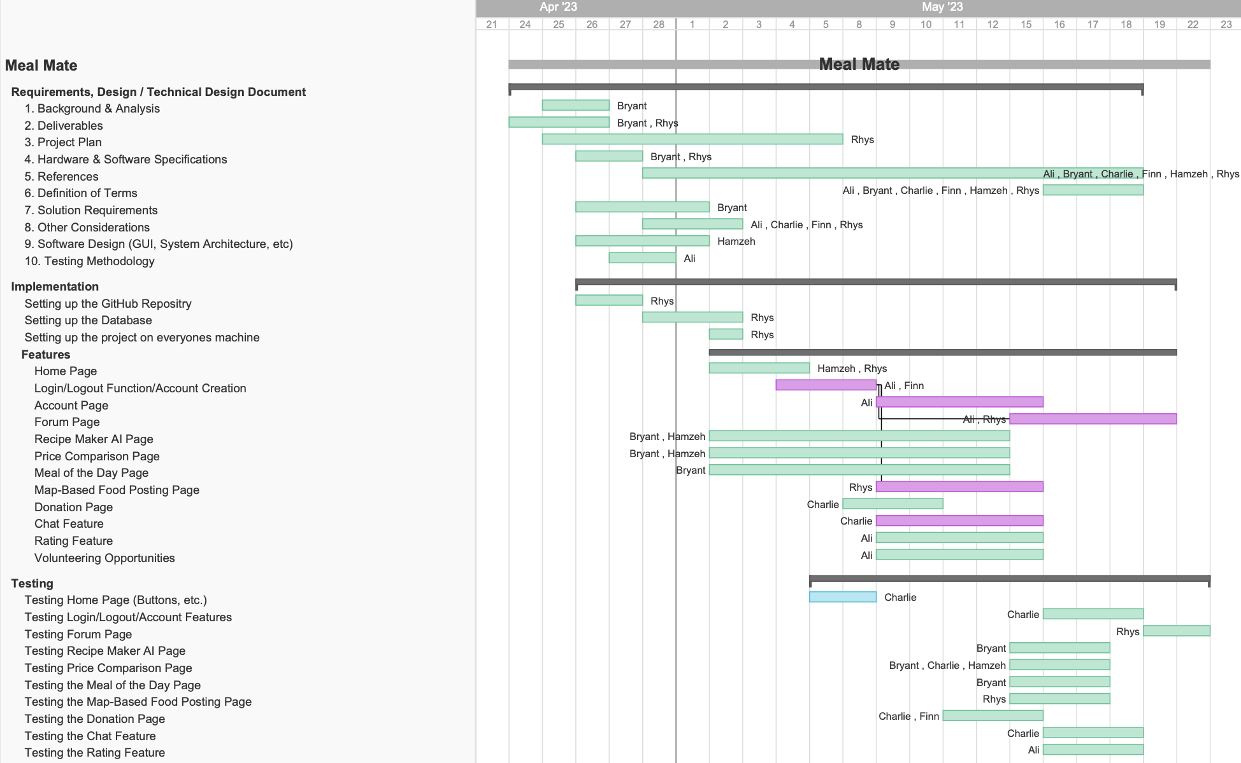

Figure 5

# Hardware and software platforms to be used for developing and running your solution

* 1. **Hardware Specifications** – what devices have you used to test and develop your system? What is the back end of your system running on?

| **Device** | **Operating System** | **Memory** | **Display Resolution** | **GPU** | **CPU** | **Storage** |
| --- | --- | --- | --- | --- | --- | --- |
| Macbook Pro 15-inch, 2019 | MacOS Ventura 13.2.1 | 16GB | 2880x1800 | Radeon Pro 555X | i7 | 256GB SSD |
| PC | Windows 11 | 16GB | 1920x1080 | RX 580 | Ryzen 5 3600 | 1TB HDD  250GB SSD |
| PC | Windows 11 | 16GB | 1920x1080 | GTX 1070 | i7-7700K | 1TB HDD  1TB SSD |

* 1. **Software** – what software have you used to develop your system (with references given to the software)

| **Software** | **Version** |
| --- | --- |
| Pycharm Professional Edition | 2023.1 |
| Django | 4.2.1 |
| Vue | 5.0.8 |
| Python | 3.10 |
| Node.js | 18.16.0 |
| Git | 2.33.0 |
| GitHub |  |
| MariaDB |  |
| MySQL | 8.0.31 |
| Docker | 4.19.0 |
| npm | 9.5.1 |
| pip | 23.1.2 |
| brew | 4.0.17 |
| Figma |  |
| Google Chrome | 113.0.5672.93 |
| ChatGPT | 4.0 |
| LucidChart |  |

# 

# **References**

1. Kitche. “Food Waste App | Kitchen App | Kitche App | Food Waste, Kitche,” n.d. https://kitche.co/.
2. “Food Waste App | Save Money on Food | Kitche App,” September 6, 2022. https://kitche.co/hacks/.
3. play.google.com. “Foodiverse - Apps on Google Play.” Accessed May 19, 2023. https://play.google.com/store/apps/details?id=com.foodcloud.foodiverse.app&gl=IE.
4. “Ginger Hack,” September 7, 2022. https://kitche.co/ginger-hack/.
5. Harvard T.H. Chan. “Food Waste.” The Nutrition Source, 2017. https://www.hsph.harvard.edu/nutritionsource/sustainability/food-waste/.
6. “Https://Foodiverse.net/,” n.d. https://foodiverse.net/.
7. www.toogoodtogo.com. “Join Our Food Waste Movement,” n.d. https://www.toogoodtogo.com/en-gb.

# **Definition of terms**

all terms used within the document.

1. **Food Waste** - edible food that is discarded/thrown away during the retail or consumption phase
2. **Food Surplus** - edible food that is in an excess amount of quantity compared to what is needed/consumed.
3. **Brute force attack** - is a trial and error method used to obtain a password.
4. **Map-based-food-posting** - The page where users can post spare food they want to give away and the location will appear on the map

# Solution requirements

* 1. **Functional Requirements**

| **ID** | **Description** | **Priority**  **(H, M, L)** | **Supplier**  **Compliance**  **(Full, partial or will not be delivered)** | **Supplier**  **Comment** |
| --- | --- | --- | --- | --- |
| 1 | User Authentication and Verification | H | Full |  |
| 2 | Create, read and update contents | H | Full |  |
|  | Recipe Maker AI | M | Full | We will be using OpenAI’s API |
| 3 | Forum | H | Full |  |
|  | Comparing Produce Prices | M | Partial | We will not be delivering it fully as there is no way for us to collect data on the daily fluctuating prices of the groceries |
| 4 | Daily Food Recommendation | H | Full |  |
| 5 | Donate Spare Food Page | H | Full |  |
| 6 | Map-based-food-posting | M | Full |  |
| 7 | Donate | L | Partial | Donate Page will exist and users can enter an amount to donate. |
| 8 | Chat Feature | M | Full | Full functionality, cant handle high load. |
| 9 | Volunteer Opportunities | M | Full |  |

* 1. **Non-Functional Requirements**

| **ID** | **Description** | **Priority**  **(H, M, L)** | **Supplier**  **Compliance** | **Supplier**  **Comment** |
| --- | --- | --- | --- | --- |
| 1 | Security | L | Full |  |
| 2 | Quick Performance | L | Partial | Performance is mostly affected by the server(hardware) and the traffic |
| 3 | Rating system for the food | L | Full |  |
| 4 | User-Friendly system | L | Partial | Important for user experience but not critical. |
| 5 | Scalability | L | Partial | Important for the project to be produced in a way that can be expanded, depending on success. |
| 6 | Compliance | L | Partial | compliance with relevant legal requirements. |

# Other considerations

* 1. **Assumptions**

Our primary assumption for this project is that the users of Meal Mate will be based in Newcastle Upon Tyne and that these users will have reliable internet access to connect to our website. This project’s features the Recipe Maker AI, price comparison between supermarket products, food sharing and chat feature are primarily designed and implemented with this specific user base in mind.

We plan to extend the functionality to other cities in the future, but the initial user experience and functionality are best tailored to Newcastle users. Additionally, we're assuming that users will be comfortable with the concept of sharing leftover food with complete strangers and will actively engage in chat discussions to coordinate the pickup and rating of the shared food alongside the use of the forum to actively discuss new ways to limit food waste and tips to save money.

* 1. **Constraints and Dependencies**

The project uses Figma for its initial web design which will later be converted to HTML which could cause significant differences between the two designs due to the differences between both design tools. To ensure the final web design closely align with the Figma design, it will require additional time and resources from the team members. The website's development is constrained by the use of Django and Vue, which may limit certain design or functionality decisions. Furthermore, the price comparison page won't be fully functional as there is currently no way for us to gather data for fluctuating prices from supermarkets, which could limit the users' understanding of price differences across stores. Moreover, the project's geographic scope is currently limited to Newcastle upon Tyne, meaning users outside this region may not have the complete user experience we intended.

Moreover, the website depends on several external APIs. The recipe maker relies on an AI model, the price comparison feature requires supermarket data, and the food-sharing feature depends on the Google Maps API. Any changes or issues with these could affect the website features and affect the user’s experience. The chat feature and forum may depend on certain protocols, APIs, or libraries, adding to the list of dependencies. The user experience and website functionality are also dependent on user-provided data, such as leftover ingredients for the AI recipe maker, location data for the food-sharing feature, and user contributions for the chat and forum features. Changes or inaccuracies in this user-provided data could impact the effectiveness and usability of these features.

# 

# 

# 

# **9. Software Design**

9.1 System Architecture – describe design decisions (Architecture diagram)

**Architecture diagram**

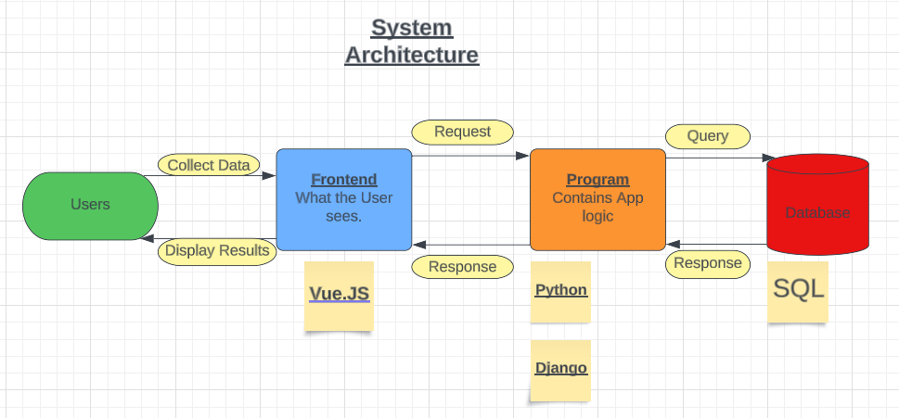

Figure 6

The users will see html pages that have been called by a script. Important information that gets displayed will come from user input as well as stored information. The system architecture highlights how the project focusses on connecting information rather than highlighting new.

9.2 High-level overview of how the functionality and responsibilities of the system are partitioned and assigned to components (deployment diagram, component diagram)

**Deployment Diagram**

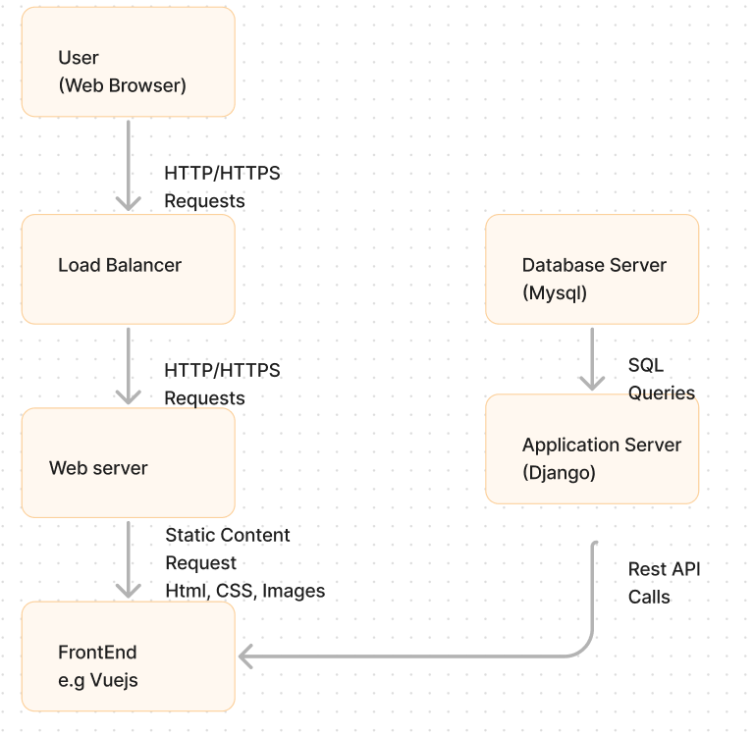

The users can access the website through their web browser. The web server serves the front end and handles the client’s requests while the application server which was implemented with Django, communicates with the database server and APIs.

Figure 7  
  
 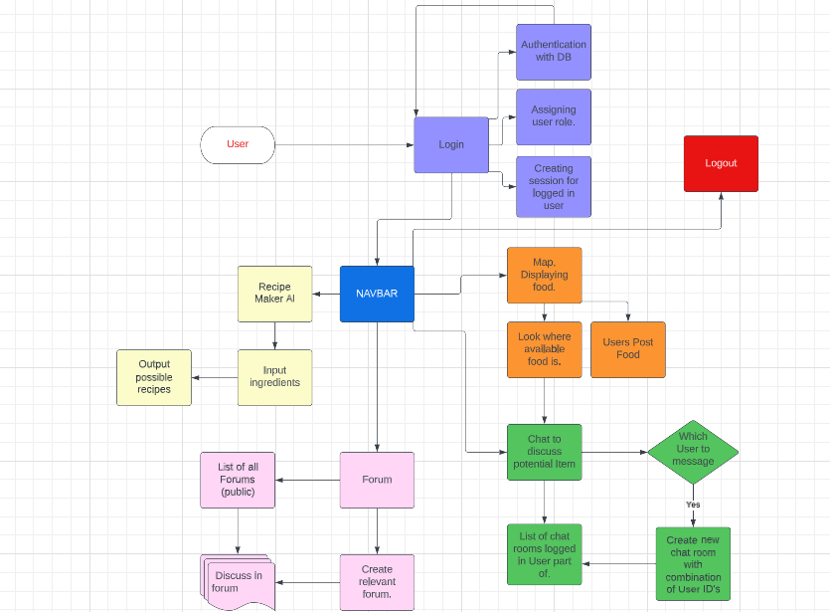

**Component Diagram**

This component diagram highlights how important functions interact with eachother and explains briefly how each component works. The website uses the navbar to navigate across all functional components. However, it is important to not that most components are connected to the database which is where important information on users and food will be stored.

Figure 8

9.3 Package and Class diagrams which show dependencies between components

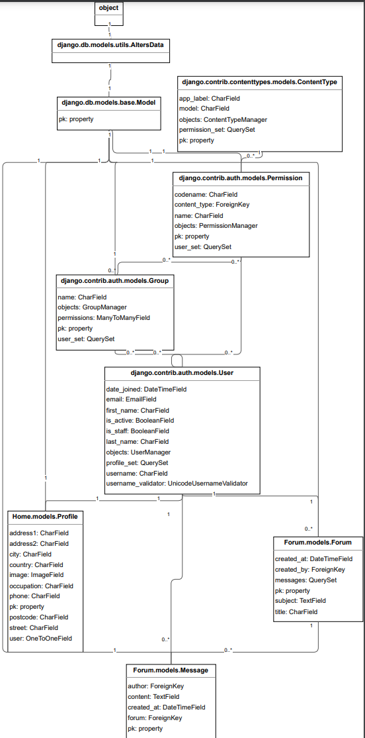

Figure 9

9.4 Show the dynamic behaviour of the system (sequence diagrams that show communication between objects. Activity diagrams that show the state of objects).

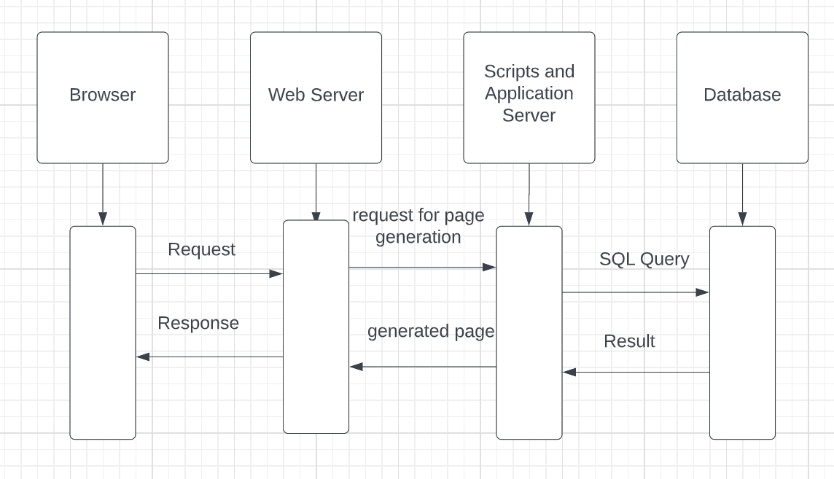

Figure 10

When a user uses the website amd does an activity like using the price comparison page for example. This browser will sent a request to the web server, which will communicate with the application server to retrieve the relevant price information from the database. The database, which is responsible for storing relevant information, receives the Query and will fetch the necessary data for it. Once the data is fetched, it will then be sent back to the application server which then processes it for display which will then be sent to the web server and will be responded back to the browser.

9.5 GUI, Human Interface Views – Describe how the user accesses functionality

**NB:** Remember to associate aspects of design to the requirement number that they fulfil – communicate how your design meets the customer requirements.

1. **Homepage:**

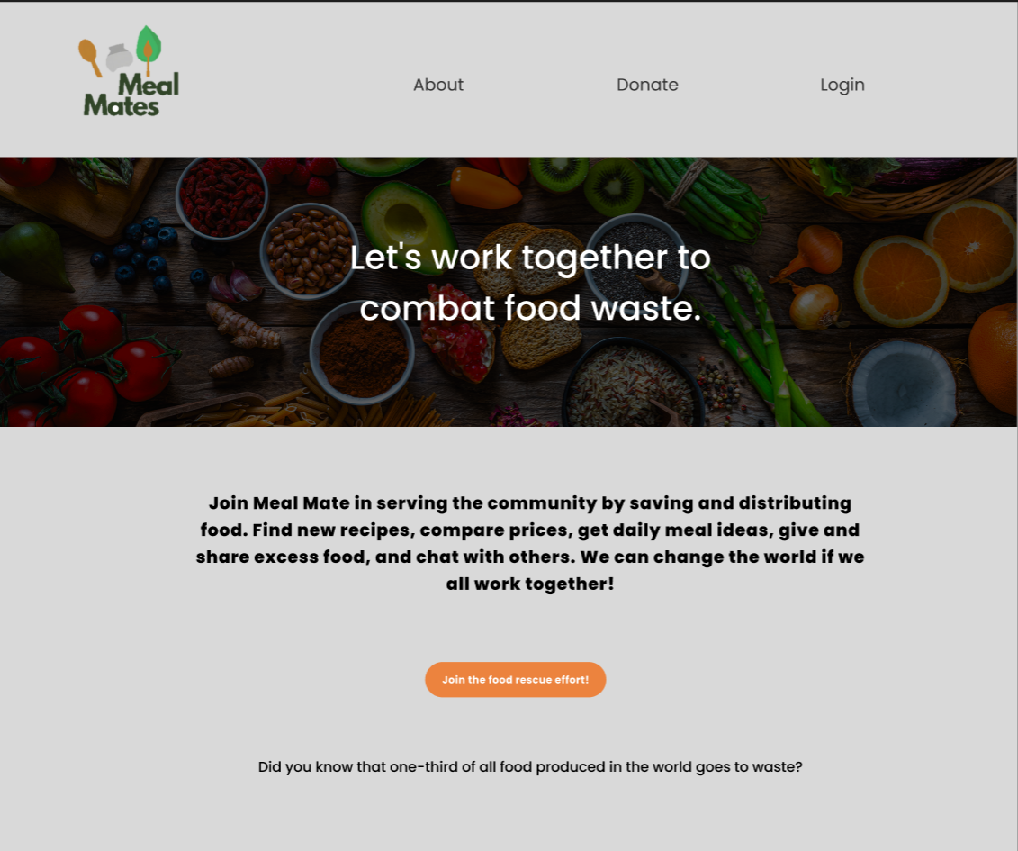

The Homepage's role is to serve as the user's entry into the site. It features a basic layout with a navigation bar that allows users to simply browse across the website and displays the primary purpose of the website. Because of the simple style, the website's key aim is highlighted without any extra features, ensuring users have a smooth experience meeting the “User-Friendly system” requirement.

Figure 11

1. **Login page:**

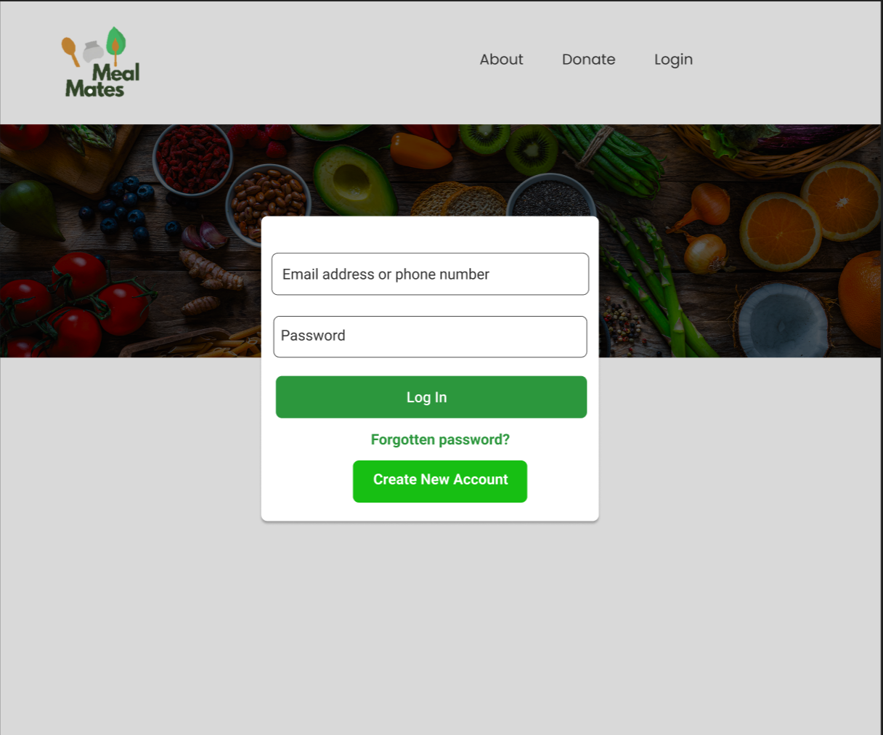

The login page's major goal is to provide a safe and practical means for the user to access the website's vital functions and personal information. The page is vital because it meets a non-functional security requirement by preventing unauthorised users from accessing sensitive information. The login page will include a safe means for the user to reset his password and a restricted number of login attempts to combat brute force assaults. Overall this page meets the functional requirement “User Authentication and Verification” since it ensures that the user is authenticated to access the website's main features.

Figure 12

1. **Account creation page**:

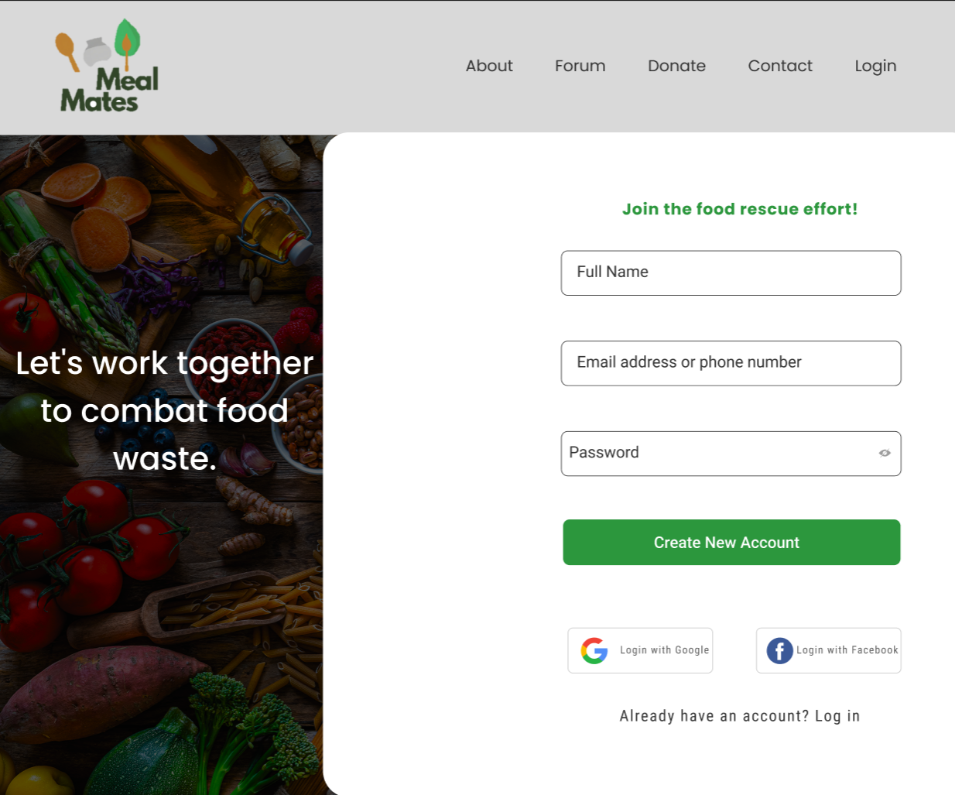

By providing a simple and secure registration process, the Registration page meets the non-functional requirement "User-Friendly system". It aims to make account creation and user registration secure. Users may register using their Gmail or Facebook accounts to make the process more user-friendly and enable speedier registration without filling out a form. Additionally, because consumers trust Google and Facebook's security standards, they could feel more comfortable signing up with those credentials. Additionally, a password strength indicator guarantees that the user selects a strong password that is challenging to guess or break using brute force assaults, reducing the likelihood of a breach.

Figure 13

1. **Recipe Maker AI**:

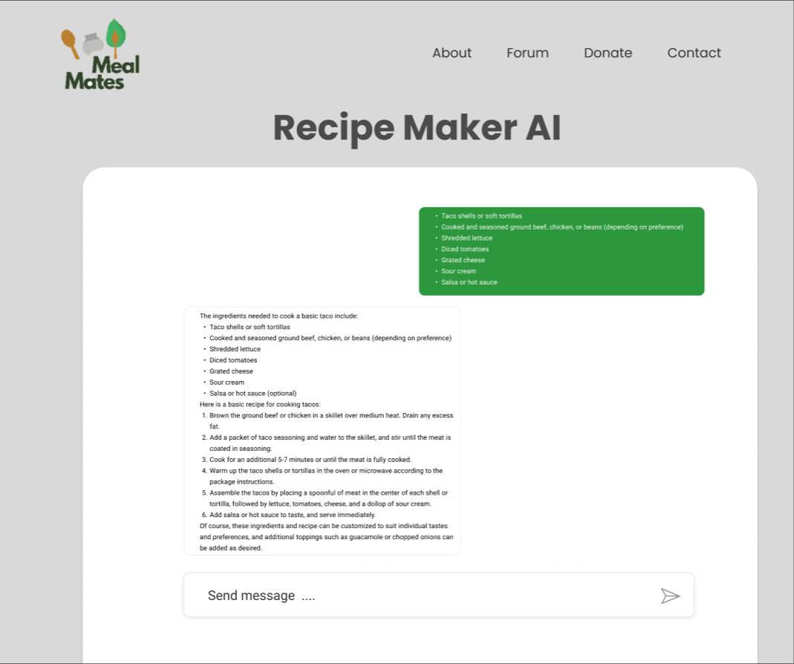

The **Recipe Maker AI** web page is designed to help users discover random recipes as well as recipes and ingredients that fit their preferences. This feature satisfies one of the website's key functional objectives by not only providing the user with an engaging experience - but also assisting users in finding recipes using their leftover ingredients, thereby minimising food waste.

Figure 14

1. **Forum page**:

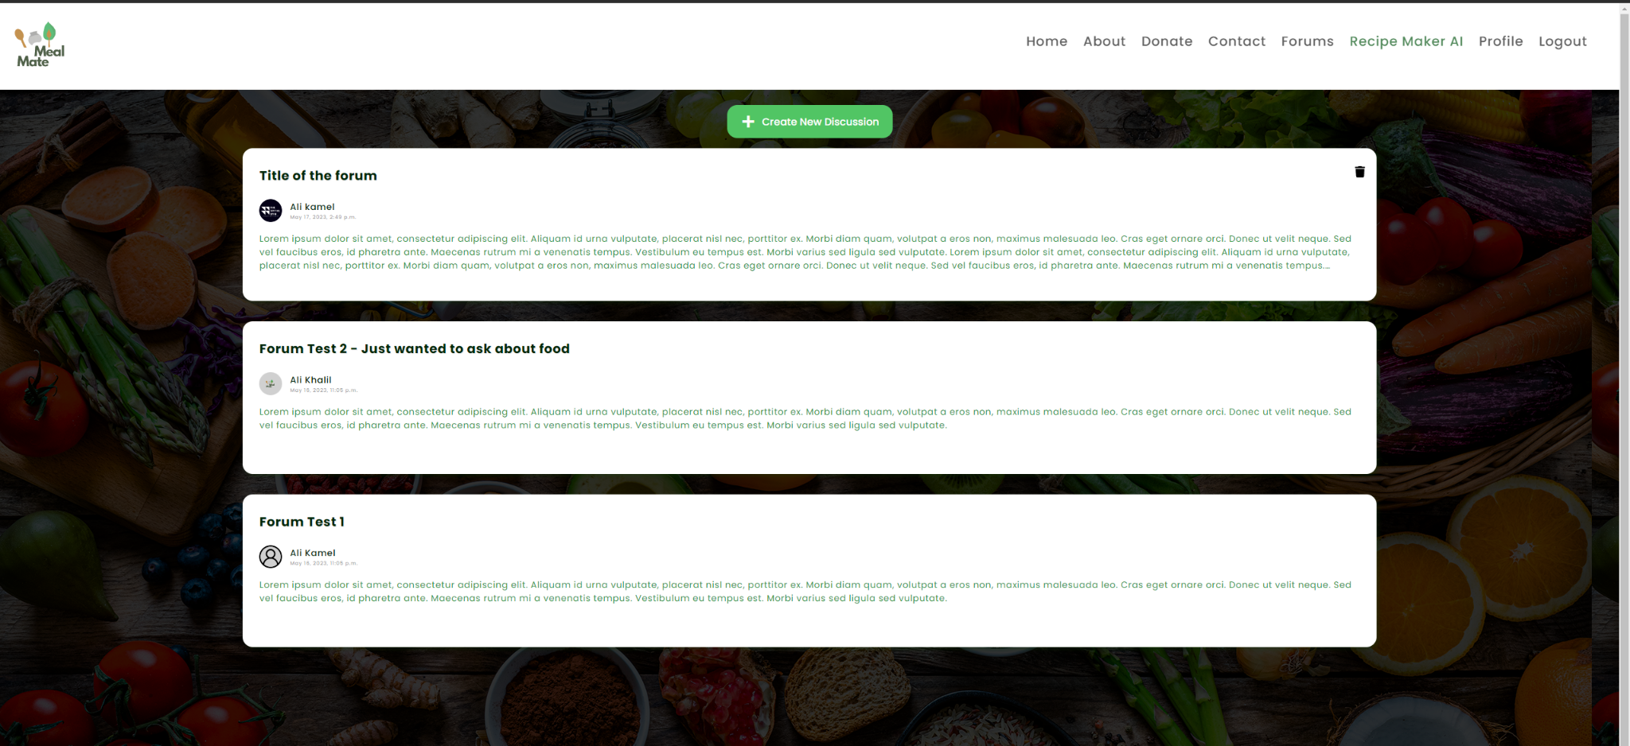

The User Forum Web Page is a dynamic meeting place for foodies to exchange ideas. It has a "Post Creation" tool that allows users to publish text and images about their leftover food experiences, satisfying the primary "Forum" criterion. This feature promotes creativity and sparks discussions about healthy eating from leftovers. The page encourages interaction by including a dynamic "Interactive Feed" that allows users to comment on posts and provide useful cooking tips, hence increasing user engagement. As a result, the Forum Page successfully offers user engagement to create a thriving community-centred platform.

Figure 15

1. **Map-based-food-posting page**:

Figure 16 Figure 17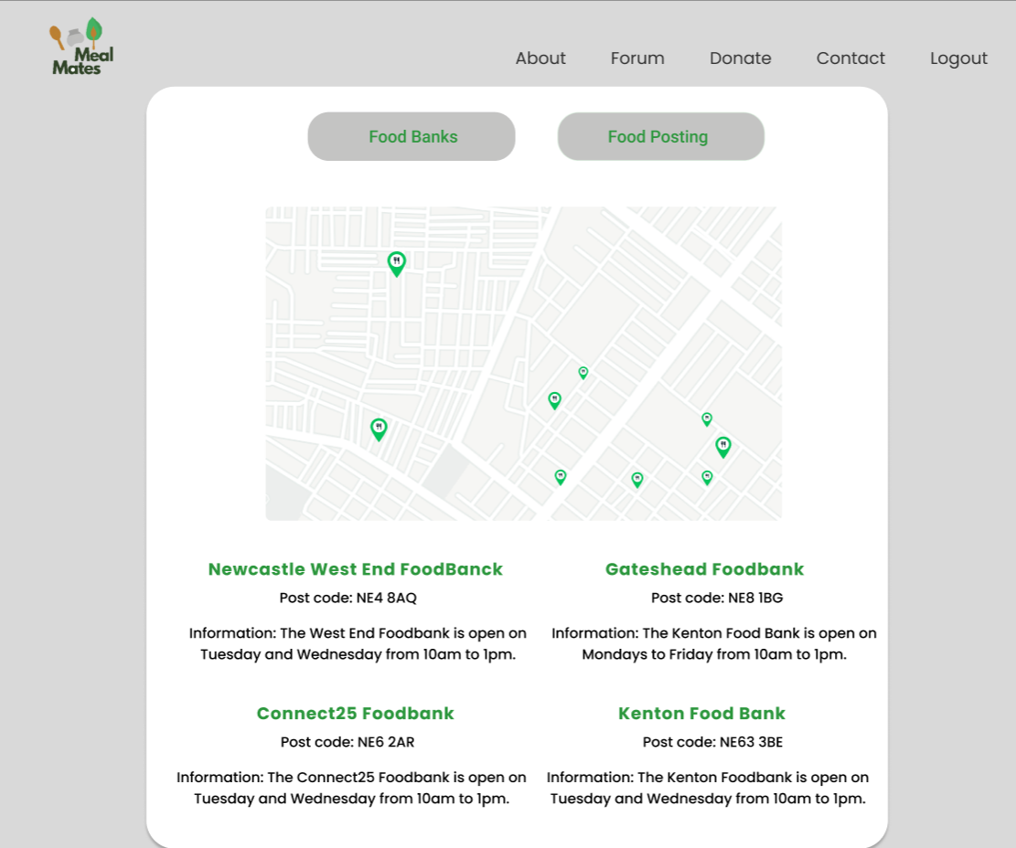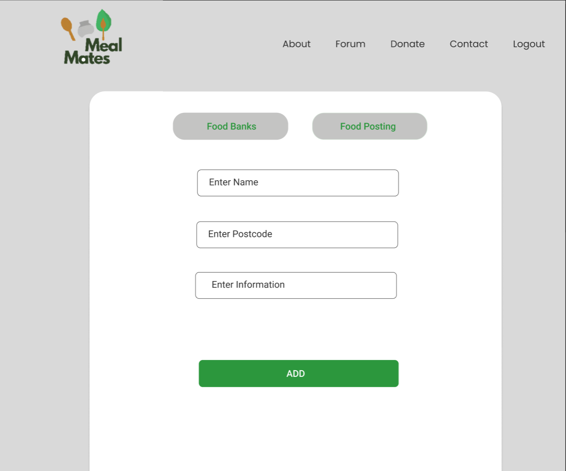

The Map-based-food-posting webpage meets the "Map" and "Create, Read, and Update Contents" functional criteria. It features a map that shows the locations of food banks in the area and information about those food banks. Users are also able to give away food they don’t want. All they need to do is provide a postcode and information about the food they are giving away. With that, an approximate location of the food giveaway will appear on the map.

1. **Chat page**:

The Chat Page, built consistently to match the whole theme of the website, satisfies the "Chat Feature" non-functional need efficiently. This website offers a live, interactive chat platform along with relevant user data, including usernames and profile pictures, to enhance the user experience. This page, which allows users to share advice on how to reuse leftover food, is engaging and helpful in developing a community devoted to decreasing food waste. All design elements are aligned with the project's aims and user demands, thus meeting the criteria.

**Custom error pages**:

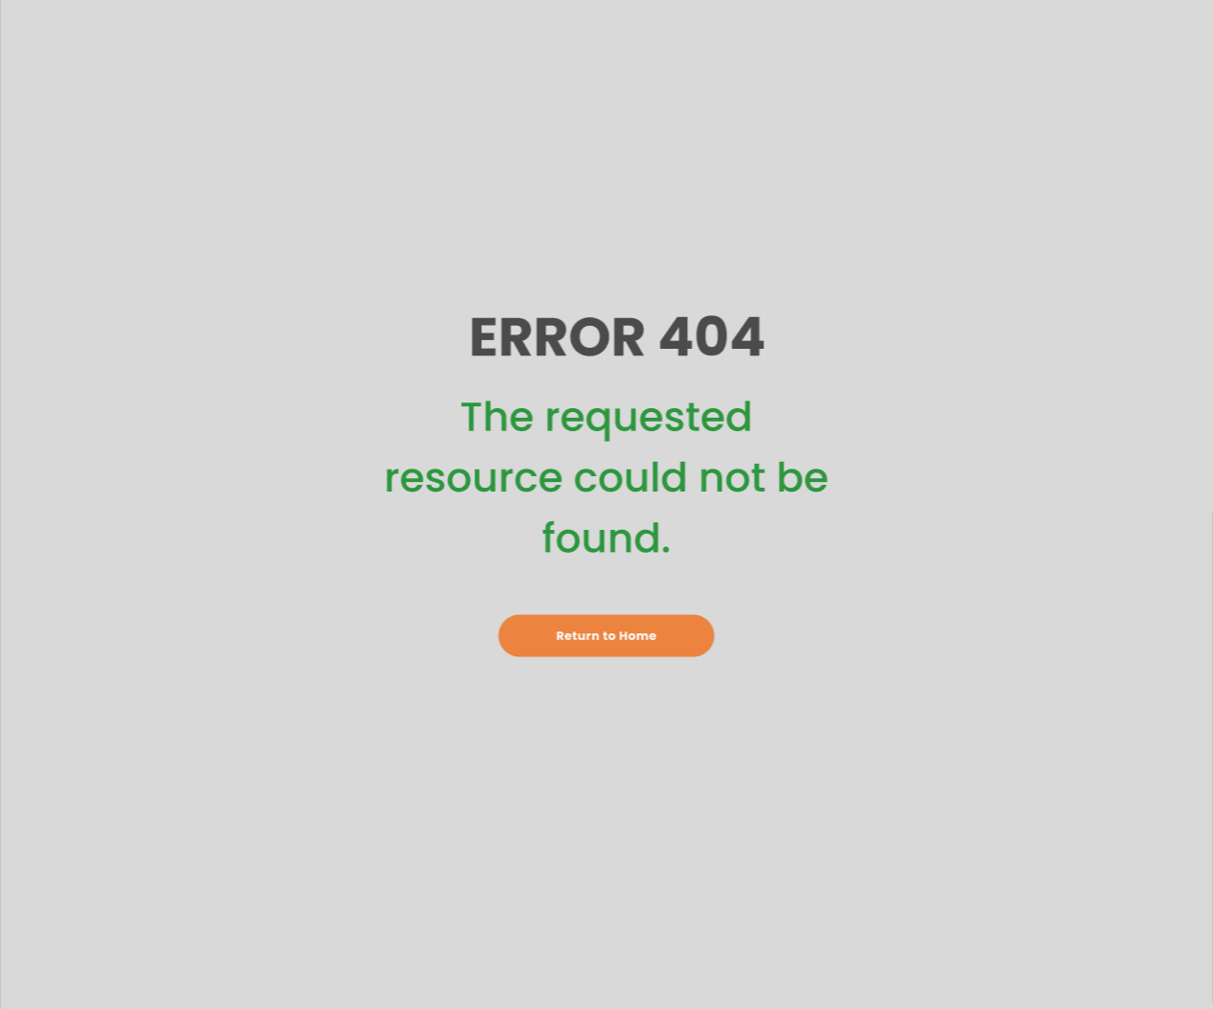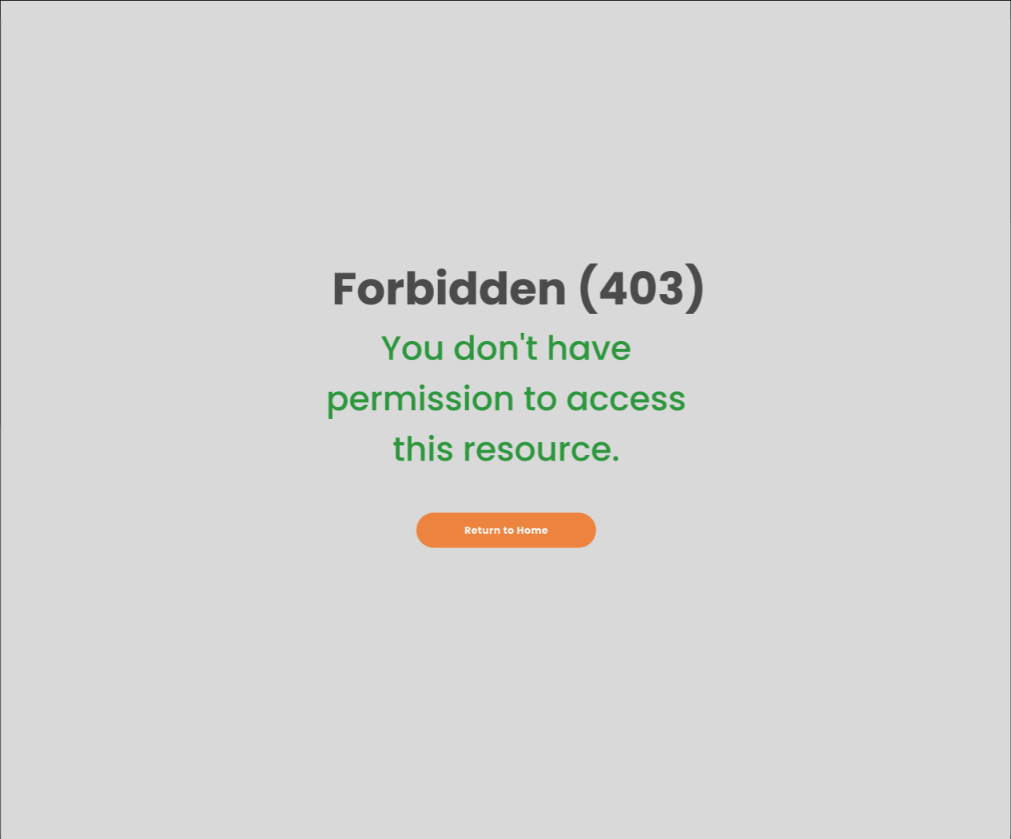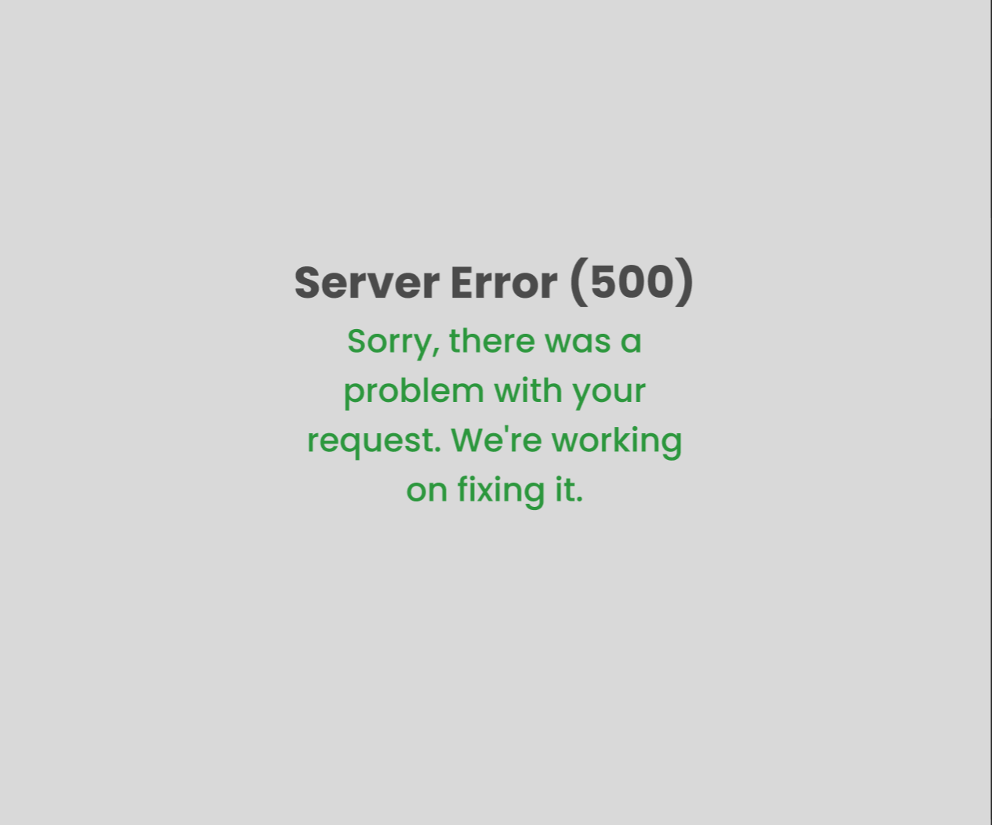

The custom error pages are intended to meet the functional criterion "user-friendly system." These pages have 404,403 and 500 errors, each representing a different issue: 'Page Not Found,' 'Forbidden Access,' and 'Internal Server Error,' respectively. Each page contains a clear and useful message that assists the user in understanding the problem. Its purpose is to keep a consistent aesthetic with the rest of the website while providing a user-friendly experience even when problems occur. On the other hand, custom error pages satisfy the non-functional criteria of "security" since they can prevent attackers from obtaining insight into the website's underlying structure and possible vulnerabilities.

9. **Donation page**:

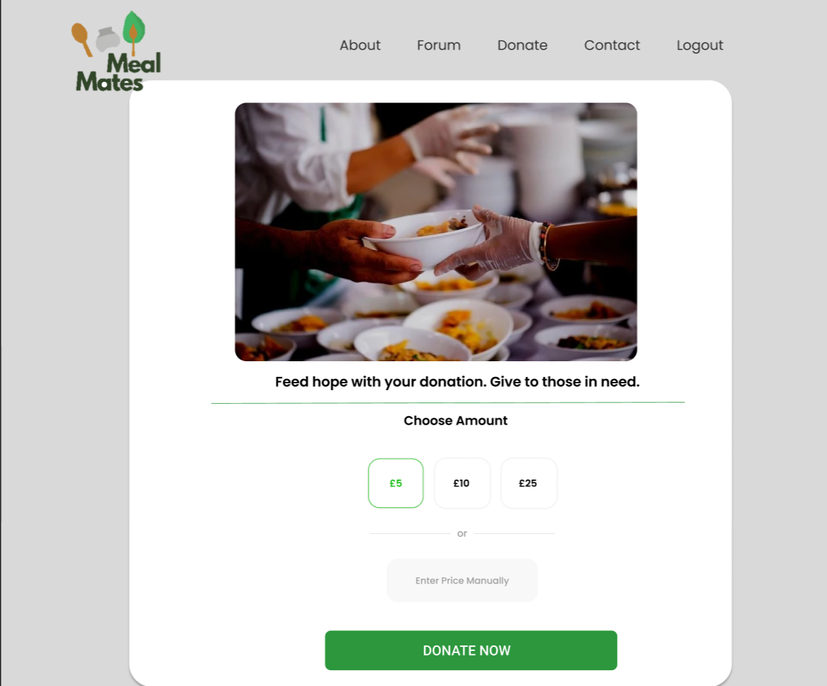

The Donation Web Page meets the "Donation Functionality" requirement of the website by being designed with consistency and user-centric principles. This page offers people a quick and safe option to contribute money to help individuals in need. The contribution page provides two options: he may select a preset amount or enter a particular amount to contribute, making the page more user-friendly thus meeting the non-functional requirement “user-friendly system”. The users may

10. **Profile page**:

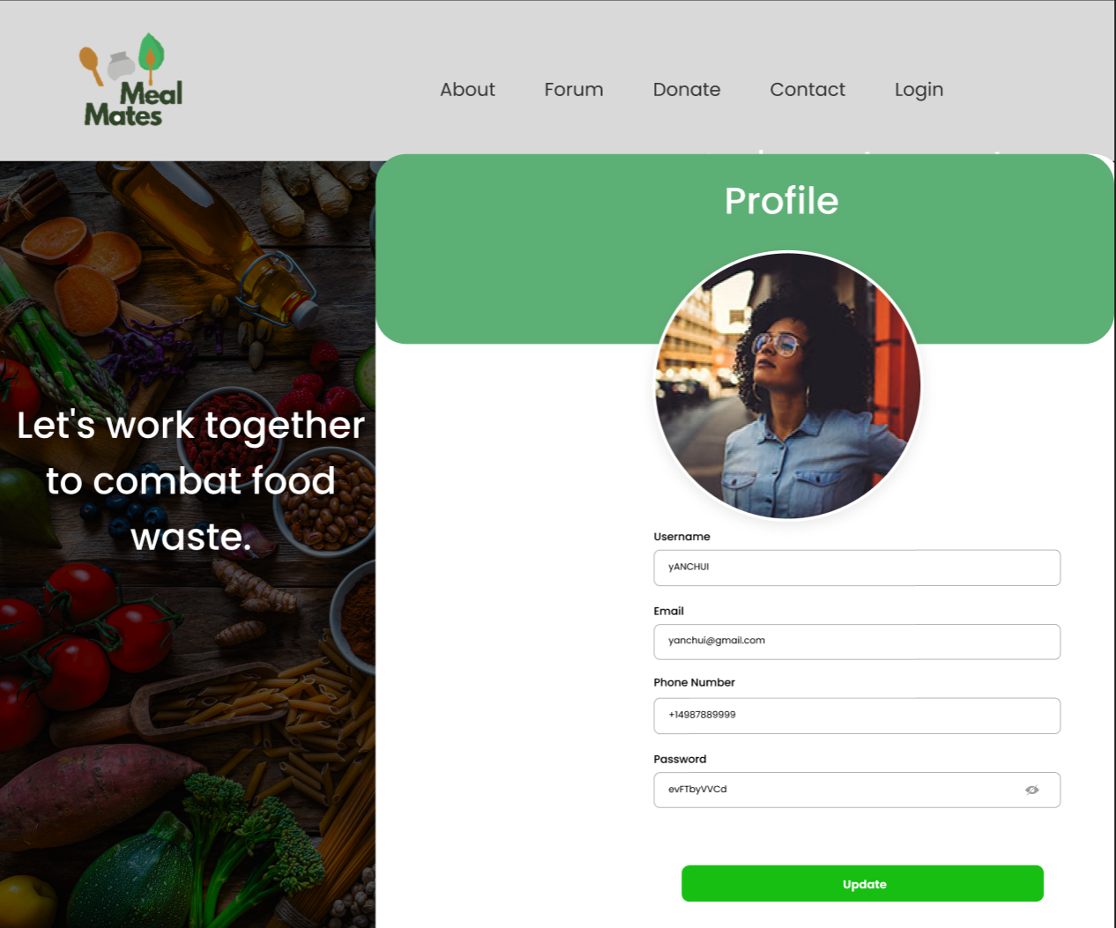

The User Profile Web Page employs a standardised design and a user-centric methodology to satisfy the functional requirements for "User Profile Management" and "Create, Read, and Update Contents.Users on this website can make private changes to their username, profile image, and phone number. Users may produce, review, and update information in real time, which gives a pleasant, personalised user experience. Users are also given authority over their profiles. The User Profile Web Page is a significant part of the platform's user experience since these capabilities are in line with the project's goals.

# 

# Testing Methodology

1. **Define testing objectives:** Identify the testing objectives for the project. This could include testing the functionality of the intended features of the system such as the login/logout feature.
2. **Write unit tests:** Write unit tests for each component of the system, including the frontend, back-end, and database. Using all tools used for developing these components.

Potential frameworks that can be used for different components of the system:

* *VueJS: can use testing libraries such as Jest, Mocha, or Cypress to write unit tests for VueJS. These libraries provide various features such as assertions, mocking, and test runners that can be used to test VueJS components.*
* *Django and Python: can use the built-in Django testing framework or third-party libraries such as pytest or unittest to write unit tests for Django and Python. These libraries provide various features such as assertions, mocking, and fixtures that can be used to test Django views, models, and other components.*
* *SQL: can use database testing frameworks such as pytest-django-db or Django's built-in testing framework to write unit tests for SQL queries and database interactions. These frameworks provide features such as fixtures, assertions, and database transaction management that can be used to test SQL queries and interactions with the database.*

1. **Conduct integration testing:** Conduct integration testing to test the interaction between the various components of the system such as testing the interaction between the front-end and the back-end. Frameworks Jest or Mocha can be used to write integration tests.

Potential integration tests that can be performed:

* *Test the API endpoints of the Django/Python back-end by sending requests from the VueJS front-end and checking if the expected response is received*
* *Test the communication between the front-end and back-end by simulating user actions (e.g., clicking buttons) and checking if the data is displayed correctly*

1. **Conduct functional testing:** Conduct functional testing to ensure that the system functions as intended. This could involve testing the login/logout functionality, account functionality, donate feature, forum feature, separate page for donation, recipe maker AI, meet up location functionality, produce price comparison feature, meal of the day feature, and chat feature. Frameworks like Selenium or Cypress can be used to write functional tests.

Potential functional tests that can be performed:

* *Testing the login/logout functionality by entering valid/invalid credentials and checking if the system behaves correctly*
* *Testing the donation functionality by submitting a donation and checking if the donation is reflected in the back-end*
* *Testing the forum functionality by creating a post and checking if the post appears in the forum*

1. **Conduct acceptance testing:** Conduct acceptance testing to ensure that the system meets the customer's requirements using frameworks such as Cucumber or Behave for writing acceptance tests. Potential acceptance tests that can be performed:

* *Test the recipe maker AI by giving it a set of ingredients and checking if it returns a list of recommended recipes.*
* *Test the meetup location functionality by selecting a location and checking if the system displays the correct meetup location.*
* *Test the produce price comparison functionality by entering the prices of different supermarkets and checking if the system displays the cheapest one.*

1. **Conduct regression testing:** Conduct regression testing to ensure that any changes to the system do not impact the existing functionality. The frameworks used for other types of testing can be used. Potential regression tests that can be performed:

* *Test the login/logout functionality after making changes to the authentication system.*
* *Test the donation functionality after making changes to the donation form.*
* *Test the forum functionality after making changes to the forum post editor.*

1. **Record results:** Record the results of each test, documenting any issues or defects identified during the testing process.
2. **Review and refine:** Review the results of the testing and determine the root of any defects. Was it a coding error? or an issue with the design of the system?. Refine and make any necessary changes to the system to address any issues or defects identified during testing.

Contribution Matrix

| **Task** | **Rhys 210129029** | **Ali 21034102** | **Finn *210137389*** | **Hamzeh *210355466*** | **Bryant *210436064*** | **Charlie *200678841*** |
| --- | --- | --- | --- | --- | --- | --- |
| 1. Background & analysis | M, R | R | R | R | C, M, R | R |
| 2. Deliverables | C, M, R | R | C, M, R | R | C, M, R | R |
| 3. Project plan | C, M, R | R | R | R | R | R |
| 4. Hardware & software | C, M, R | R | C, R | R | C, R | C, R |
| 5. References | C | R | R | R, C | C,M,R | R |
| 6. Definition of terms | C | R | R | R, C | C,M,R | R |
| 7. Solution requirements | R | M, R | C, M, R | R, M | C,M,R | M,R |
| 8. Other considerations | R | R | R | R | C,M,R | R |
| 9. Software design | M | C, M, R | C, M, R | C, M, R | C,M,R | R |
| 10. Testing methodology | R | C, M, R | R | R | R | M, R |

C = Create

M = Modify

R = Review

T = Test